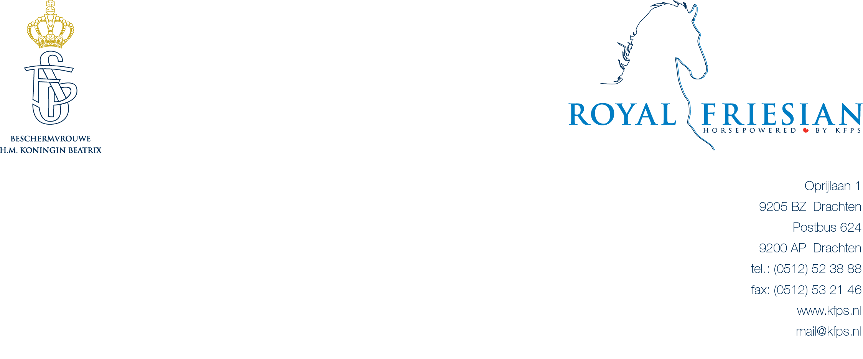

KFPS Stallion Show January 10 – 12, 2013

Headset reservation form

The Stallion Inspection has been enjoying increasing popularity amongst visitors from other countries for some years now. As studbook, we are naturally delighted with this foreign interest in our purebred stallions. A simultaneous interpretation will be provided this year, for all 3 days, in order to make the Stallion Inspection even more attractive to foreign members.
Those attending the show will be able to follow the jury’s commentary in the English language via a headset. Seize this chance to learn even more about the Friesian horse!

You can apply for this service using this form the deadline for applications is December 9th 2012.

We have a limited number of headsets, so don’t be too late! A headset costs € 20,- a day, and 3 days for € 50,--. This amount must be paid in cash at the KFPS Guest-desk in Leeuwarden. When you pick up a headset at the Guest-desk you will be asked to also pay a deposit of € 50,- per headset. After returning the headsets your deposit will be refunded. We do ask you to return the headset every day because the headsets need to be recharged at night.

Day Price Number of headsets: Total price
Thursday € 20,-
Friday € 20,-
Saturday € 20,-
All the days € 50-

KFPS membership number : R-
Street : No :
Postcode : City :
Country :
Email :
Tel : Fax :
Signature : Date :

Please send this form before December 9th , 2012 to KFPS, Eveline van Kooten, Postbus 624, 9200 AP Drachten, The Netherlands Fax:+31-512-532146 mailto:evelinevankooten@kfps.nl

