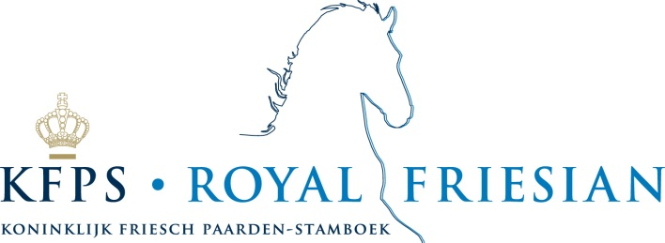

KFPS Stallion Show January 8-10, 2015
Headset reservation form

The Stallion Inspection has been enjoying increasing popularity amongst visitors from other countries for some years now. As studbook, we are naturally delighted with this foreign interest in our purebred stallions.
A simultaneous interpretation will be provided this year, for all 3 days, in order to make the Stallion
Inspection even more attractive to foreign members.
Those attending the show will be able to follow the jury’s commentary in the English language via a
headset. Seize this chance to learn even more about the Friesian horse!

You can apply for this service using this form the deadline for applications is December 1th 2014.

We have a limited number of headsets, so don’t be too late! A headset costs € 20,- a day, and 3 days for € 50,--. This amount must be paid in cash at the KFPS Guest-desk in Leeuwarden. When you pick up a headset at the Guest-desk you will be asked to also pay a deposit of € 50,- per headset. After returning the headsets your deposit will be refunded. We do ask you to return the headset every day because the headsets need to be recharged at night.

Day Price Number of headsets: Total price
Thursday € 20,- _________________ __________
Friday € 20,- _________________ __________
Saturday € 20,- _________________ __________
All the days € 50- _________________ __________

English / German*

KFPS membership number : R- ________________________________________________
Street: _________________________________________________ No : ______________
Postcode : _____________________ City :_______________________________________
Country : _________________________________________________________________

Email : ___________________________________________________________________

Tel : _____________________________ Fax : ___________________________________

Signature : ___________________________ Date : _______________________________

Please send this form before December 1th , 2014 to KFPS, Eveline van Kooten, Postbus 624, 9200 AP Drachten, or e-mail evelinevankooten@kfps.nl

